PREDICTING TEA OWNER EARNINGS IN SRI LANKA USING MACHINE LEARNING: AN INTEGRATED ANALYSIS OF PRODUCTION DYNAMICS AND LOCAL–FOREIGN MARKET FACTORS

Research Project Proposal
presented to the Faculty of Computing
NSBM Green University
in partial fulfillment of the requirements for the degree of
Bachelor of Science (Hons) in Computer Science
by
Thapassara Muhandiramlage Gayantha Nadeemal Muhandiram

December, 2025

Table of Contents
1. Introduction 1
1.1 Background of the Study 1
1.2 Motivation 1
1.3 Study Objectives 2
2. Literature Review and Research Gap 3
2.1 Overview of Existing Studies 3
2.2 Identification of Research Gap 3
3. Research Problem and Questions 4
3.1 Main Research Problem 4
3.2 Specific Research Questions 4
4. Research Strategy and Methodology 5
4.1 Research Strategy 5
4.2 Research Methodology Framework 5
4.3 Data Collection Methods 5
4.4 Data Preprocessing / Preparation 6
4.5 Model Development / Implementation 6
4.6 Evaluation 7
4.7 Ethical considerations 8
4.8 Limitations of the study 8
5.Timeline 9
References 10

1. Introduction

1.1 Background of the Study
Tea is one of the most significant agricultural incomes in Sri Lanka. Tea contributes for millions of people’s livelihoods in the country. Sri Lanka, is well known globally for Ceylon Tea, exports tea to a diverse range of international markets, making the industry highly sensitive to fluctuations in global demand, exchange rates, and geopolitical conditions. At the same time, tea production is influenced by local factors such as climatic conditions, production costs, labor availability, and auction market dynamics.
Sri Lanka is one of the world’s leading tea exporters, and the tea industry contributes substantially to national income, foreign exchange earnings, and rural employment (Central Bank of Sri Lanka, 2023). Tea export prices are affected by multiple interdependent factors, including international demand and supply dynamics, Colombo Tea Auction prices, global economic conditions, exchange rate volatility, climatic variations, and geopolitical events (FAO, 2021). Traditionally, tea owners rely on historical auction prices, intuition, and limited market reports to estimate future income. However, this approach often fails to capture the complex interactions between production dynamics, domestic auction behavior, and foreign market conditions.
Recent advancements in Artificial Intelligence (AI) and Machine Learning (ML) have enabled predictive modeling systems capable of processing large-scale, multidimensional datasets to generate accurate forecasts. AI-based predictive models have been successfully applied in agricultural price forecasting, commodity market analysis, and export demand prediction (Zhang et al., 2019; Kumar & Thenmozhi, 2021). While machine learning has been widely applied to commodity price forecasting and yield prediction, there is a lack of research focusing on “predicting tea owner earnings”, which represent the most critical economic outcome for producers. This study seeks to address this gap by developing an integrated ML-based framework that combines local and international market factors with production data to forecast tea owner income in Sri Lanka.

1.2 Motivation
The motivation for this research is both practical and academic. From a practical view, tea owners; particularly smallholders—face significant income uncertainty due to uncertain market conditions and rising production costs. Accurate income predictions can support better decision-making related to production planning, resource allocation, and financial management.
From an academic perspective, existing studies mainly focus on tea price forecasting or export volume analysis, with limited emphasis on income-level prediction. Furthermore, most models lack explainability, reducing their trust and adoption among stakeholders. As a computing student with an interest in applied machine learning and decision-support systems, this research aims to bridge this gap by applying explainable AI techniques within a real-world agricultural and economic context.

1.3 Study Objectives
Primary Objective
To develop a robust machine learning–based predictive model to estimate tea owner earnings in Sri Lanka by integrating production dynamics, local market behavior, and foreign market factors.

Secondary Objectives
- To identify and analyze key market and production variables influencing tea owner income.
- To collect and preprocess historical tea production, auction, export, and economic data from local and foreign sources.
- To develop and compare multiple machine learning models for income prediction.
- To evaluate model performance using appropriate statistical and predictive accuracy metrics.
- To apply explainable AI techniques to interpret prediction results.
- To propose an AI-driven decision-support framework for tea owners and policymakers.

2. Literature Review and Research Gap

2.1 Overview of Existing Studies
Many studies have invented the application of AI and machine learning techniques in agricultural and commodity price forecasting sectors.
Zhang et al. (2019) demonstrated that machine learning regression models surpass the traditional statistical methods in agricultural commodity price prediction because their ability to model non-linear relationships and tree based and deep learning models. Similarly, Kumar and Thenmozhi (2021) applied deep learning techniques such as Long Short-Term Memory (LSTM) networks to predict commodity prices under fluctuating market conditions.
Research focused on tea markets has primarily examined auction price forecasting. Perera et al. (2020) utilized ARIMA and neural network models to forecast Colombo Tea Auction prices, reporting improved accuracy when hybrid models were employed. Another study by Jayasinghe and Abeysekera (2022) highlighted the impact of exchange rates and global demand on Sri Lankan tea exports using econometric models. Hevner et al. (2004) and Peffers et al. (2007) proposed Design Science Research methodologies suitable for developing and evaluating IT-based artifacts such as decision-support systems.
Export market analysis studies indicate that global economic indicators, currency fluctuations, and geopolitical factors significantly affect export commodity earnings (World Bank, 2022). Decision Support Systems (DSS) developed for agriculture typically provide trend analysis or price forecasts but rarely address producer-level income estimation (FAO, 2021).

2.2 Identification of Research Gap
Although existing literature confirms the effectiveness of AI in price and market forecasting, there is a notable lack of research focusing on predicting the actual income received by tea owners. Most studies concentrate on auction or export prices without considering producer-specific outcomes. Additionally, existing models do not integrate multiple export market variables into a unified AI-based income prediction framework. This research addresses these gaps by proposing a producer-centric AI model that estimates tea owner income using export market factors, thereby enhancing real-world applicability and decision support.

3. Research Problem and Questions

3.1 Main Research Problem
How can machine learning be used to accurately predicting tea owner earnings in Sri Lanka by integrating analysis of production dynamics and local–foreign market factors?

3.2 Specific Research Questions
- What production, local market, and foreign market variables most significantly influence tea owner income?
- Which machine learning models provide the highest prediction accuracy for tea owner earnings?
- How does income prediction performance vary across different tea-producing regions?
- How can explainable AI techniques improve transparency and trust in income prediction models?

4. Research Strategy and Methodology

4.1 Research Strategy
This research adopts a Design Science Research (DSR) strategy, because the primary objective is to design a Machine Language based predictive system. And also, it solves a problem in real life through a innovative technological solution.

4.2 Research Methodology Framework
The proposed system follows a modular machine learning pipeline, consisting of:
- Data Acquisition
- Data Preprocessing
- Feature Engineering
- Model Development
- Model Evaluation & Validation
- Explainability & Insight Extraction
- Decision Support Integration
Each module is independently scalable and reproducible.

4.3 Data Collection Methods
The data use in the system development will be obtained from the existing datasets, as secondary data. The data and their sources are mentioned below.
Data Category | Source
Tea production & yield | Sri Lanka Tea Board
Auction prices | Colombo Tea Auction reports
Export & importer data | Sri Lanka Customs, ITC Trade Map
Climate variables | Department of Meteorology Sri Lanka
Macroeconomic indicators | Central Bank of Sri Lanka, World Bank

4.4 Data Preprocessing / Preparation
Data Cleaning
- Removal of duplicate records
- Outlier detection using IQR and Z-score methods
- Handling missing values:
  - Mean/median imputation (numeric)
  - Forward fill for time-series data
Data Harmonization
- Currency normalization (USD → LKR)
- Inflation adjustment for monetary values
- Temporal alignment across datasets
Data Transformation
- Log transformation for skewed income distributions
- Normalization / standardization (Min-Max, Z-score)
- One-hot encoding for categorical variables (region, tea type)

4.5 Model Development / Implementation
Target Variable Definition
Primary Target:
- Tea owner earnings (monthly or quarterly net income)
Optional Targets:
- Revenue per kg
- Income volatility index
Model Development
Baseline Model
- Multiple Linear Regression
- Purpose: Benchmark performance and interpretability
Tree-Based Models
- Random Forest Regressor
- XGBoost Regressor
- Advantages:
  - Non-linear pattern capture
  - Robust to multicollinearity
Time-Series Deep Learning Model
  - Long Short-Term Memory (LSTM)
  - Input: Sequential feature windows
  - Output: Future income predictions
Model Training Strategy
  - Train-validation-test split (70-15-15)
  - Time-aware splitting to avoid data leakage
  - Hyperparameter tuning using GridSearch / Bayesian Optimization
Implementation Technologies
Layer | Technologies
Data Processing | Python, Pandas, NumPy
Machine Learning | Scikit-learn, XGBoost
Deep Learning | TensorFlow / PyTorch
Explainability | SHAP
Visualization | Matplotlib, Plotly
Deployment (Optional) | Streamlit / Flask

4.6 Evaluation
Evaluation Metrics
- Mean Absolute Error (MAE)
- Root Mean Squared Error (RMSE)
- Mean Absolute Percentage Error (MAPE)
- R-squared (R²)

Validation Techniques
- Rolling window cross-validation
- Region-wise error analysis
- Residual diagnostics

4.7 Ethical considerations
- Bias assessment across regions
- Transparent model explanations
- Data privacy and aggregation safeguards
- Responsible AI usage guidelines

4.8 Limitations of the study
The project has several risks which would impact on the project’s success. The model’s accuracy depends on data quality and availability. Without sufficient high-quality data, accuracy and trustworthiness of machine learning models will be lessened. To overcome this risk, I will use officially published comprehensive datasets.
There is also limitation in availability of accurate datasets in different factories. The accuracy in historical data also directly affect on the performances of the system.
Sudden global market disruptions may affect predictive reliability. Also, the changes in global political environment and climate may directly affect the outcome of the system. The findings may be context-specific to Sri Lanka’s tea export industry.
In addition, there are technical challenges that could lead to potential delays. This would Addressed through continuous testing and development is performed by using modular development practices where each integrated component can be tested and debugged in isolation.

5.Timeline
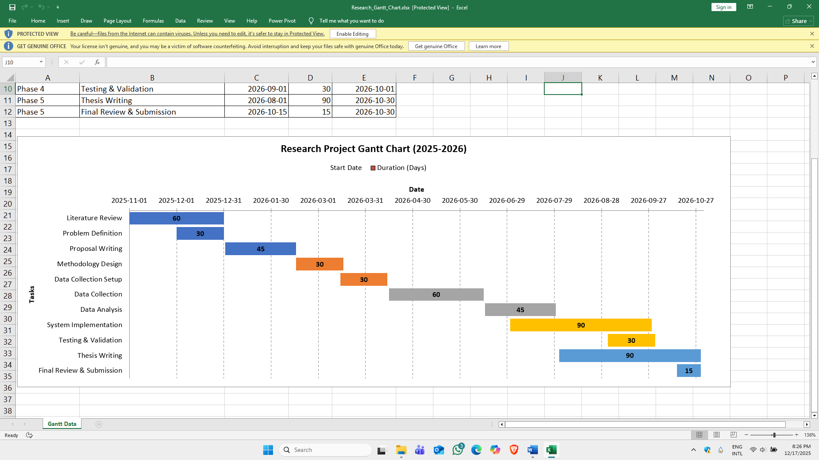
The project will be executed over one year, with milestones including dataset preparation, model training, system development, and deployment. Regular reviews will ensure progress aligns with project objectives. A detailed Gantt chart outlining tasks, deadlines, and dependencies is included here,

Link to the Gantt chart (Accessible):

References
Central Bank of Sri Lanka. (2023). Annual Report.
FAO. (2021). Digital Agriculture and Commodity Forecasting.
Zhang, Y., Wang, J., & Zhao, X. (2019). Machine learning approaches to agricultural price prediction. Computers and Electronics in Agriculture, 162, 103–111.
Kumar, M., & Thenmozhi, M. (2021). Forecasting commodity prices using deep learning models. Applied Economics, 53(5), 523–540.
Jayasinghe, P., & Abeysekera, R. (2022). Export market determinants of Sri Lankan tea. Journal of Agricultural Economics, 14(2), 45–60.
Hevner, A. R., March, S. T., Park, J., & Ram, S. (2004). Design science in information systems research. *MIS Quarterly*, 28(1), 75–105.
Peffers, K., Tuunanen, T., Rothenberger, M. A., & Chatterjee, S. (2007). A design science research methodology. *Journal of Management Information Systems*, 24(3), 45–77.
World Bank. (2022). *Global Commodity Markets Outlook*.

